The Faculty of Pre-Hospital Care International Elective Bursary
Elective Placement Report, Jan / Feb 2026
Georgia McCullough | City St George’s, University of London
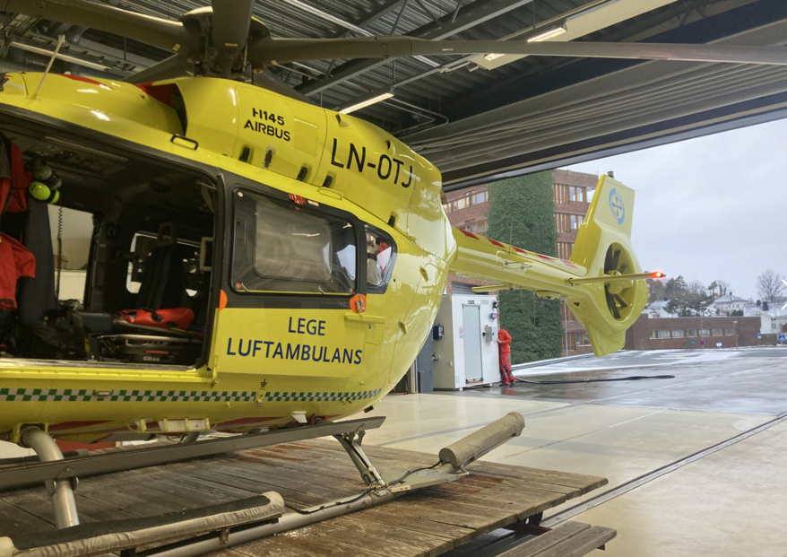
I was lucky enough to spend my placement in Southern Norway, at Sørlandet Sykehus in Kristiansand and Arendal. My time was split between Anaethesiology and Intensive Care, the Ambulance Department, HEMs and the Critical Care cars.
The two hospitals together cover the residents of Agder and other nearby areas (population around 320,000), with services shared between to the two hospitals. The air ambulance is based in Arendal, with the “akuttmobil” (Critical Care Car) based in Kristiansand. Southern Norway’s varied geography, changeable weather and rurality often poses a challenge in transferring patients to definitive care with the Prehospital department covering the coast and islands extending into the more mountainous areas further north. This means that calls can be logistically complex and require careful planning to transfer patients in the most safe and efficient way - multistep transfers between ambulances and the helicopter are not uncommon.
Over the course of the placement, I had the opportunity to practise airway management, IV access, take part in cardiac arrest and major haemorrhage simulations as well as attending teaching on surgical airways, IO, ultrasound. I saw a huge variety of cases both on and off the road including major trauma, septic shock, necrotising fasciitis, anaphylaxis, head injury requiring RSI, chest pain, a breech birth, respiratory distress and reduction of an ankle fracture-dislocation at a bus stop in minus 7 degrees!
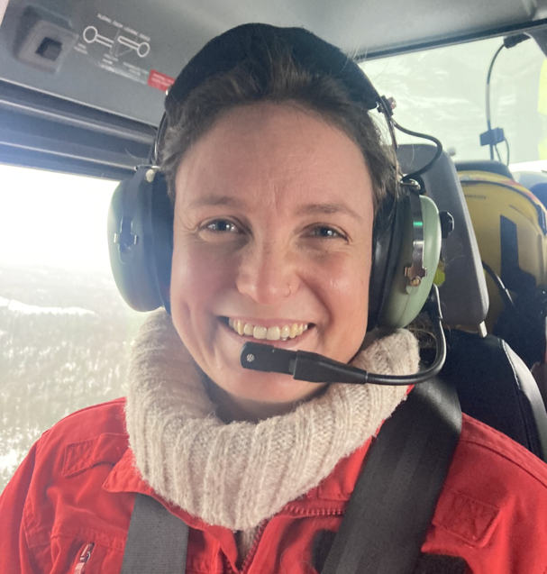
The Critical Care Cars were brought in to provide advanced interventions, but it was emphasised that interventions should be done on scene only when necessary and not delay transfer to definitive care - however given the logistical challenges and long distances some interventions, such as RSI, may be considered earlier to avoid intubating mid-transfer. The car is staffed by an Anaesthesiologist and a Paramedic. The team themselves listen to all ambulance calls and decide between them where their attendance might be useful and made it clear that their role was to support the paramedics and provide advanced interventions rather than take on a leadership role.
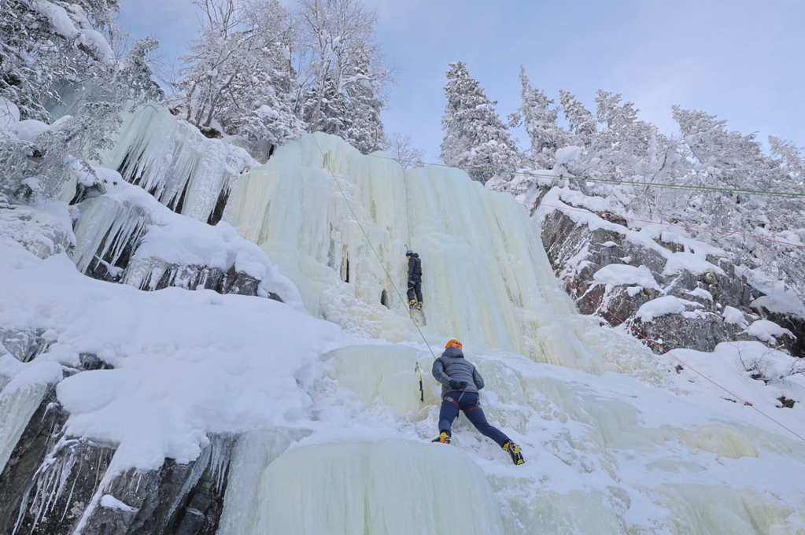
The set up was very similar to HEMs, where the decision to attend a call was a joint decision between the pilot, rescue paramedic and the anaesthesiologist. When a call came in, the HEMs crew would gather in the control room. There they had access to the most current weather information – including access to webcams across southern Norway and were able to determine the height and composition of the clouds to help with decision making and route planning. I was then fortunate enough to join them for a training flight and was taught about all the safety considerations such as how to approach the helicopter safely, in flight communication and got to practise one skid landing (and wading through waist deep snow to find our “patient”). Despite the weather I was lucky to get some incredible views of the islands and coast around Arendal.
Whilst the anaesthesiologists are employed through the hospital, the pilot and rescue paramedic are employed by the Norwegian Air Ambulance foundation. The air ambulance team has a huge skill set – evidenced an equipment room with everything from ice axes and crampons to diving kit. The importance of communication, teamwork and situational awareness was strongly emphasised.
This placement was an incredible learning opportunity for which I am so grateful. I gained confidence in clinical skills and learnt new ones such as ultrasound IV access. I understand more about recognising and managing critically ill patients both in and out of hospital, as well as more complex decision making and considerations in the pre-hospital environment. I even managed to experience some of Norway’s friluftsliv -love of the outdoors- spending my weekends skiing, hiking and ice climbing.
I’d like to thank RCS Faculty of Pre-hospital care for the support, the Ambulance crew at Arendal, ICU and anaesthesiology teams at Arendal and Kristiansand, Akuttmobil and HEMs teams, Kirsti Strommen Holme from Norskluftambulanse, and most of all Dr. Lars Jacobsen for all your enthusiasm, commitment and hard work to make this placement happen.

