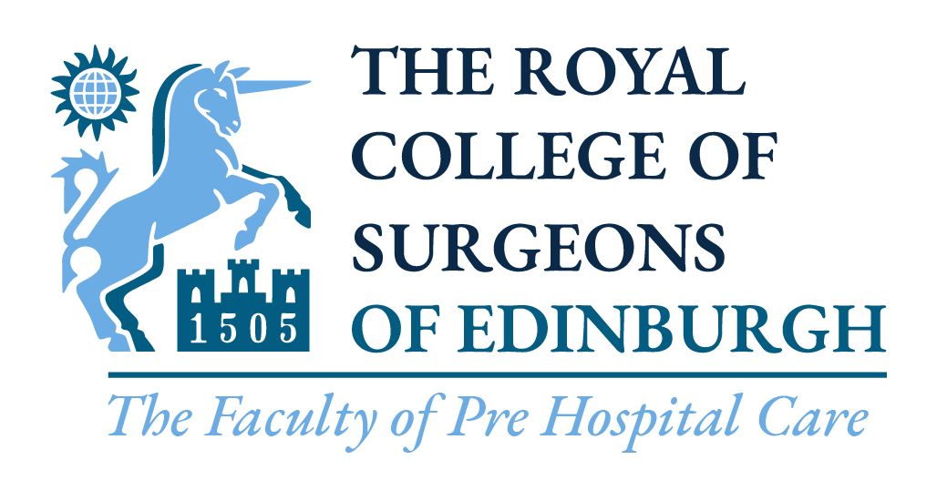
A Faculty of Pre-Hospital Care, the Royal College of Surgeons of Edinburgh
Facilitated Elective in Pre-Hospital Emergency Medicine 2024
Three places available two in Wales and one in London
What you can expect from this elective placement:
- A once in a lifetime opportunity to gain insight into a rapidly evolving speciality by experiencing many aspects of Pre-Hospital Emergency Medicine.
- There are many components that will make up your elective timetable which will vary between regions.
  - Shifts with the either the London or Welsh Ambulance Service NHS Trusts in their Double Crew Ambulances and Rapid Response Vehicles
  - Time with Advanced Paramedic Practitioners of different types
  - Time spent with the Hazardous Area Response Team (HART) paramedics
  - Operational Management Experience and time in Control Centres
  - The possibility of some time spent with Police Firearms units, Fire Service and other units acting as an expert patient or instructor depending on your skill set
  - Opportunities to teach and instruct on skills or trauma assessments
  - Time spent in the Faculty of Pre-Hospital Care in Edinburgh, with the opportunity to assist in the FIMC and DIMC examinations
  - Observer shifts with local Pre-Hospital Responders and Care Delivery Systems
- There may be opportunities for you to carry out an audit whilst on your elective placement.

Important Notice before applying: Please be aware that should the position with COVID-19 change then these electives may be withdrawn – this could be at short notice

What will be expected of you:
- To put in the time and effort organising the schedule for your elective once you have been given the appropriate contacts
- To be enthusiastic and interested in the activities you undertake
- To be well prepared for sessions you will be teaching or instructing
- Many individuals will have put a large amount of time and effort into ensuring your elective placement is possible, so you must be punctual and turn up to EVERY shift you have organised appropriately kitted out – you will be given help with kit.
- This elective placement relies upon your predecessor having made a good impression to allow the elective placements to continue, make sure you do not jeopardise this opportunity for the next student
- To write a report to feature on the FPHC website
Please be aware that you are unable to apply for a specific region. This will be allocated by the panel depending on the outcome of your application process.

How to Apply for this Elective:
- Answer the following questions with each answer being 200 words or less. Applications exceeding this word count for any question will be disregarded. The word count applies to the body of each section, including any headings.
  - Why you would like to undertake this elective?
  - What area of interest would you be keen to complete an audit on during this elective?
  - What do you think the likely challenges have been for pre-hospital practitioners during the covid-19 pandemic?
Any applications exceeding the maximum word count in any section will immediately be disregarded – the word count applies to the body of each section including any headings

If you are successful in this part of the application process you will receive a phone call from someone associated with the Faculty of Pre-Hospital Care, who will conduct a short interview with you to assess if you are an enthusiastic individual who will be suited to this exciting elective opportunity.
This is a competitive process – the final decision will be made by a panel comprising previous successful elective students, an FPHC Executive Officer, the Chair of the FPHC Student and Junior Trainee Committee and a Senior Member of this year’s elective placement organisation with whom this elective is undertaken.
The elective will last for 4 to 6 consecutive weeks on mutually convenient dates in 2024 but you MUST also be available to spend the week of 3 July 2024 at the Faculty of Pre-Hospital Care in Edinburgh. Failure to do this will lead to a report sent to your medical school.
The Faculty of Pre-hospital Care is pleased to offer a £250 bursary to the successful student. Details on how to access the bursary funds will be noted in the confirmation letter.
Please send your completed application electronically to fphc@rcsed.ac.uk to be received by 12:00 Friday 27 October 2023. Please attach evidence that you are currently a student at a UK medical school and are eligible to undertake the elective if you are successful.
The decision will be made, and the successful applicant notified no later than Friday 17 November 2023.

