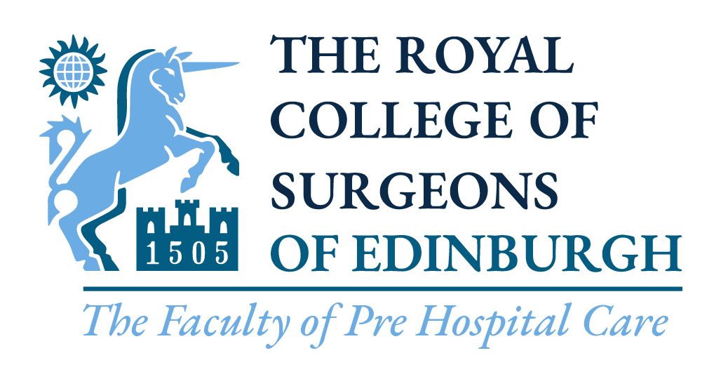

Immediate Medical Care Generic Crowd Doctor
& Practitioner Course
Spring 2023 Application Form

Spring Course: Castle Park New Attendee Course cost: £650.00
Armthorpe Road Recertification cost: £650.00
Doncaster
DN2 5QB

Course Format: Online content to view before attending, in-person Saturday 25th February & Sunday 26th February 2023.

Name (please print): ___________________________________________________________________________

GMC Number ___________________________________________________________________________

Name of club/organisation: ___________________________________________________________________________

Contact Address: ___________________________________________________________________________
(inc. Postcode)
___________________________________________________________________________

___________________________________________________________________________

___________________________________ Postcode ___________________________

Contact Numbers: Work _______________________________ Mobile _____________________________

Home _______________________________

Email address: ___________________________________________________________________________

Please tick appropriate box:

I will attend the ‘Crowd Doctor & Practitioner Course’
as a new attendee

I will attend the ‘Crowd Doctor & Practitioner Course’
as a recertification

Should I pass the course, I agree for my full name and e-mail address to be provided to Sporting Governing Bodies (e.g., RFU) for the sole purpose of being approached for possible Crowd Doctors/Practitioners activities and events (please check as appropriate):
Yes |  | No

Signed: ……………………………………………………… Date: …………………………………………………...

Name (please print): ……………………………………………………………………………………………………...

IMPORTANT notes:
Please note: A course place will only be allocated on receipt of full payment for the course. Please send your completed form by email to fphc@rcsed.ac.uk. Once received we will let you know if your application has been accepted and will offer you a variety of methods to make payment.If you are unable to attend the course please inform us two weeks prior to the course. If you do not inform us at this time and do not attend on the day a £50.00 fee will apply to cover costs of the course. You will not be entitled to a refund unless there are exceptional circumstances.

