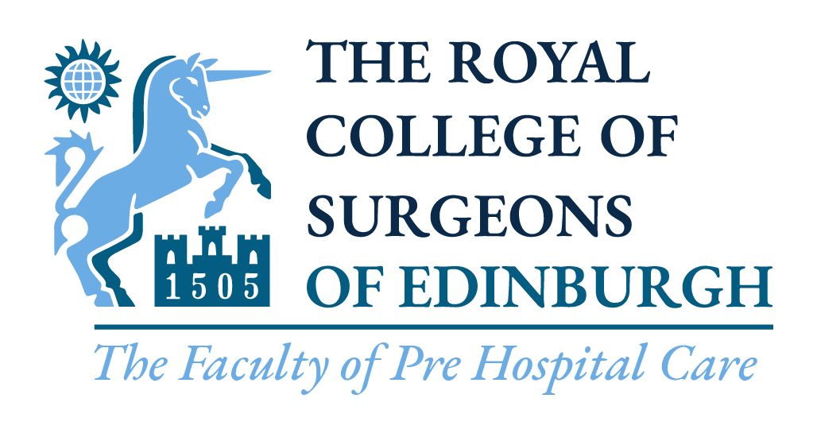

Regional Advisory Group Applications

Background
The Faculty of Pre-Hospital Care (FPHC) is looking for enthusiastic individuals to fill-in the vacant representative positions in the following regions:
- Scotland
- North West
- Northern Ireland
- East of England
- East Midlands
- West Midlands
Regional representatives are the link between the Faculty office and the regions. Their main role is to co-ordinate and promote high quality education and teaching in pre-hospital care, as well as effectively integrate the efforts of all participants in pre-hospital care in their respective regions.
Representatives can be from any professional background involved in the delivery of pre-hospital care, and at any level of training / practice. They are nominated for a period of 3 years and report to the FPHC Regional Advisory Group Chair, Mr Gordon Ingram.
Other responsibilities include:
- Contribute to co-ordination and promotion of educational events in their areas
- Actively share information with FPHC to enable update of regional web pages
- Promote other resources on the FPHC website, for example exams and accreditation, being cognisant of the fact that this is now all multidisciplinary
- Engage with relevant practitioners and groups in the region, for example:
- Links with universities - such as representing FPHC at University Open days – ideal to do with Student Rep’s and especially with progress in some areas integrating PHEM into the undergraduate curriculum
- Participation in undergraduate teaching opportunities and link with undergraduate schemes
- Engaging with regional Major Trauma Networks and sharing educational / M&M meeting details via the web page
- Encouraging PHEM trainees, especially at completion of their training programmes to contribute to the regional groups, and making contact via the Training Programme Directors to welcome any new PHEM trainees to the region
- Events teams and voluntary aid groups
- Ensuring close links with local operational BASICS Schemes - and seeking agreement for links to those schemes to be on the regional web pages, along with any opportunities for interested folk to get practical experience.

To Apply:
Please fill in the below form and return to the Faculty Office along with your CV via fphc@rcsed.ac.uk before 4p.m. on the 16th September 2022.

Any questions on the role please send an email to the Regional Advisory Group Chair, Mr Grodon Ingram: gordon.ingram@rcsed.net

Faculty of Pre-hospital Care
Regional Advisory Group
Representative Application
Region:

Applicant Information
Full Name: |  |  |  |  |  |  | Date:

Address:
Street Address

 | City |  | Postcode

Phone: |  | Email

Education and Employment
University: |  | Course:

Current year of study: |  | of |  | Or graduated? | YES | Complete a) and b)

a) Current Role / Grade:
b) Current Hospital:

Why would you like to join the Group?
200 words maximum

What role do you think the group should serve to the Pre-Hospital Care Community in your region?
200 words maximum

Please submit this form and your CV to fphc@rcsed.ac.uk

We will be in touch as soon as possible.

Thank you.

