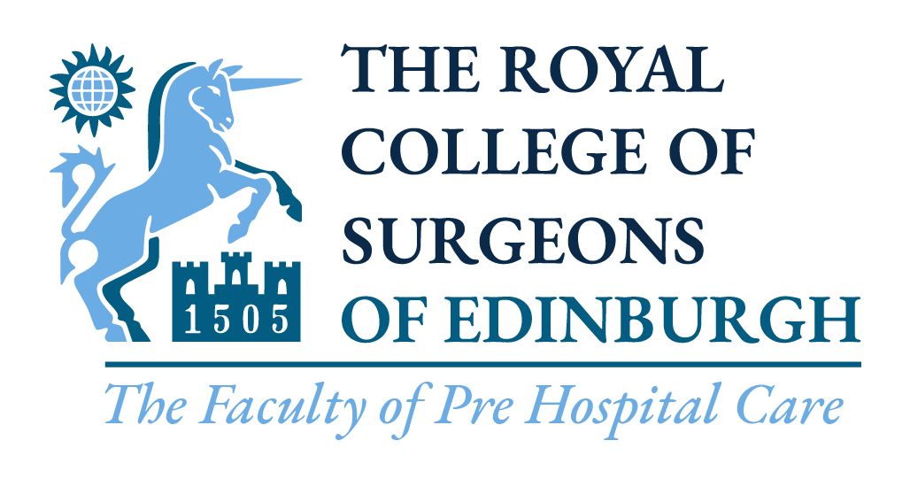

Crowd Doctor & Practitioner Course
2022 Application Form

September Course: Twickenham Stadium
200 Whitton Rd
Twickenham
TW2 7BA Full Course cost: £650.00
Recertification cost: £450.00

Name (include Title): ___________________________________________________________________________

Professional Registration
Number : ___________________________________________________________________________

Name of club/organisation: ___________________________________________________________________________

Contact Address: ___________________________________________________________________________
(inc. Postcode)
___________________________________________________________________________

___________________________________________________________________________

___________________________________

Contact Numbers: Mobile _____________________________ Home _______________________________

Email address: ___________________________________________________________________________

Please tick appropriate box:

I will attend the full ‘Crowd Doctor & Practitioner Course’
Online elements, Saturday 3rd September & Sunday 4th September 2022

I will attend the recertification ‘Crowd Doctor & Practitioner Course’
Saturday 3rd September & Sunday 4th September 2022

Should I pass the course, I agree for my full name and e-mail address to be provided to Sporting Governing Bodies (e.g., RFU) for the sole purpose of being approached for possible Crowd Doctors/Practitioners activities and events (please check as appropriate):
Yes |  | No

Signed: ……………………………………………………… Date: …………………………………………………...

Name (please print): ……………………………………………………………………………………………………...

IMPORTANT notes:
Please note: A course place will only be allocated on receipt of full payment for the course.
Please send your completed form by email to fphc@rcsed.ac.uk. Once received we will let you know if your application has been accepted and will offer you a variety of methods to make payment.
If you are unable to attend the course please inform us two weeks prior to the course. If you do not inform us at this time and do not attend on the day a £50.00 fee will apply to cover costs of the course. You will not be entitled to a refund unless there are exceptional circumstances.

