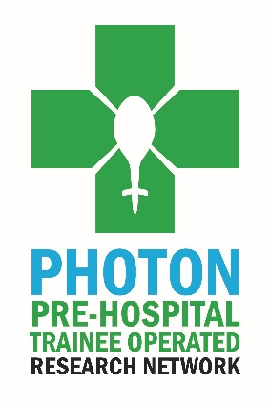
PHOTON Committee positions

Are you a non-consultant grade doctor working in pre-hospital emergency medicine and interested in pre-hospital research? Looking for exciting opportunities to get involved? Look no further..

We are looking to recruit three new team members onto our PHOTON committee who are enthusiastic about driving forward collaborative pre-hospital research.
We are looking for PHEM doctors (trainee or non-trainee grades) to join our team. Each committee member would be expected to get involved with PHOTON and help to raise its profile and to help in the oversight of the various and ongoing projects. Committee meetings are held quarterly remotely.

The Role of the PHOTON Group
We are a group of non-consultant grade, pre-hospital doctors who are passionate about improving the quality of pre-hospital research. In order to achieve this, we have collaborated to enable multicentre pre-hospital research to be conducted. Our members include doctors and other healthcare professionals either working in or interested in pre-hospital critical care.
We sit under the umbrella of the Faculty of Pre-hospital Care (FPHC) at the Royal College of Surgeons of Edinburgh (RCSEd). As such our information governance is guaranteed by RCSEd with oversight of research activity being provided by the Gibson Chair.
We welcome research proposals from all sources. Proposals will be reviewed on a quarterly basis and those where we think PHOTON’s resources could be useful will be added to the PHOTON research portfolio. Whilst the originators will, of course, retain their names on any published work we ask that “The PHOTON Collaborators” are also credited as an author.
To date we have two published works, with another two in the pipeline and many more to come.

THE ROLES

Social media role
We are looking for an engaged and enthusiastic social media representative to join our team. We would be looking for someone to design our new PHOTON website which will have a landing page within the FPHC, in addition to helping distribute a quarterly PHOTON newsletter to members and manage our Twitter and Facebook accounts.

Other roles
We are looking for two new committee members as the tenure for some of our current members has come to an end. Duties include sitting on the committee and attending quarterly meetings, helping in the management of current and future PHOTON projects, assisting in the future development of PHOTON. Each elected member will take responsibility for one active project, with oversight from the PHOTON chair.

Eligibility
To be eligible an individual must:
- Be registered with the GMC.
- Hold or have held a substantive post in a UK Air Ambulance or other UK Pre Hospital Critical Care organisation.
If you are interested in applying for any of these two positions, please complete the application below and send it back by email to the FPHC Office at fphc@rcsed.ac.uk before 16:00 on 20TH August 2021.
Applications will be reviewed by the PHOTON group committee.
If you would like any further information on the roles then please contact PHOTONchair@rcsed.net.

