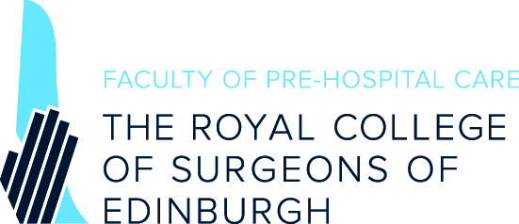

Student and Junior Doctor Group

Background
The Faculty of Pre-Hospital Care Student and Junior Group is a group of students and junior professionals within the fields of medicine, nursing, and paramedicine, who are committed to developing and extending opportunities in training and education for careers in pre-hospital emergency medicine (PHEM). As a committee of the Faculty of Pre-Hospital Care RCSEd the primary focus is to extend the work of the Faculty into the realms of students and juniors to help promote opportunities and training of the highest standard, and available as widely as possible.
The committee comprises of an Executive, made up of a Chairperson, Treasurer, Secretary, and Immediate Past Chair, who work with a group of 13 Regional Representatives.
The committee’s primary objectives are:
- Developing and disseminating standards and guidance on pre-hospital education for students and juniors.
- Supporting the creation and advancement of local, regional, and national pre-hospital education initiatives.
- Connecting junior stakeholders on a regional and national level to promote and enhance their activities.
- Providing a conduit for communication between students/juniors and the Faculty’s senior leadership.
Regional Representatives link the Faculty of Pre-Hospital Care Student and Junior committee with individuals and groups within their respective region. The role requires maintaining and growing a list of contacts in the region, and working closely with the committee executive to communicate with them. Regional representatives are responsible for:

- Maintaining contact with pre-hospital care stakeholders in their area:
- Advocating on behalf of stakeholders in their region:
- Co-ordinating local Faculty activities in their area.

Regional representatives will also be asked to undertake additional duties as identified by the executive, such as assisting with conference organisation or representing the committee at events.

Regional Representative Application

Region:

Applicant Information
Full Name: |  |  |  | Date:
 | Last | First

Address:

Street Address

 | City |  | Postcode

Phone: |  | Email

Education and Employment
University: |  | Course:

Current year of study: |  | of |  | Or graduated? | YES | Complete a) and b)

a) Current Role / Grade:
b) Current Hospital:

Why would you like to join the committee?
200 words maximum

What makes you an ideal candidate?
200 words maximum

What role do you think the group should serve to students and junior doctors in the UK?
200 words maximum

CV

Please submit this form and your CV to FPHCStudentsReps@rcsed.net

We will be in touch as soon as possible.

Thank you.

