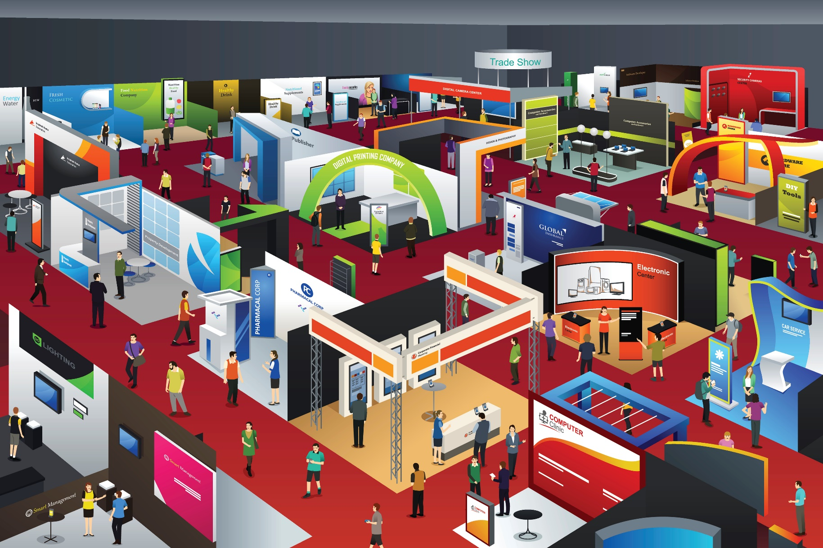

FPHC Scientific Conference

11 – 12 January 2018

Exhibitors Booking Form



|  |  |  |  |  |  |  |  |  |  |  |  |  |  |  |  |  |  |  |
| --- | --- | --- | --- | --- | --- | --- | --- | --- | --- | --- | --- | --- | --- | --- | --- | --- | --- | --- |
| **Cost** | | **Description** | | | | | | | | | | | | | | | **Amount** | |
| £750 | | Daily rate for one table with two representatives | | | | | | | | | | | | | | |  | |
| £1,200 | | Two-day rate for one table with two representatives | | | | | | | | | | | | | | |  | |
| *Rates above include refreshments and lunch for each delegate* | | | | | | | | | | | | | | | | | | |
| **Exhibitor Space and Layout** | | | | | | | | | | | | | | | | | | |
| **Table Dimensions** | | | | | | | | | | | | | | | | | | |
| **Length** | | | | | | | | | | **Width** | | | | | | | | |
| 178 cm / 70 inches | | | | | | | | | | 75 cm / 29.5 inches | | | | | | | | |
| *Please note there is insufficient room for large banners unless you purchase an additional table space to accommodate this.* | | | | | | | | | | | | | | | | | | |
|  | | | | | | | | | | | | | | | | | | |
| *Please Tick below to indicate preferred table location/s (allocated on a first come first served basis)* | | | | | | | | | | | | | | | | | | |
| **1** | **2** | | **3** | **4** | | **5** | **6** | **7** | **8** | | **9** | **10** | **11** | **12** | **13** | **14** | | **15** |
|  |  | |  |  | |  |  |  |  | |  |  |  |  |  |  | |  |
| **Exhibitor Details** | | | | | | | | | | | | **Return Address** | | | | | | |
| Company | | | | |  | | | | | | | **The Faculty of Pre-Hospital Care**  The Royal College of Surgeons of Edinburgh  Nicolson Street  Edinburgh  EH8 9DW  **Email:** [fphc@rcsed.ac.uk](mailto:fphc@rcsed.ac.uk) | | | | | | |
| Address | | | | |  | | | | | | |
| Attendees Name(s) | | | | |  | | | | | | |
| Office Tel | | | | |  | | | | | | |
| Mobile | | | | |  | | | | | | |
| Email | | | | |  | | | | | | |