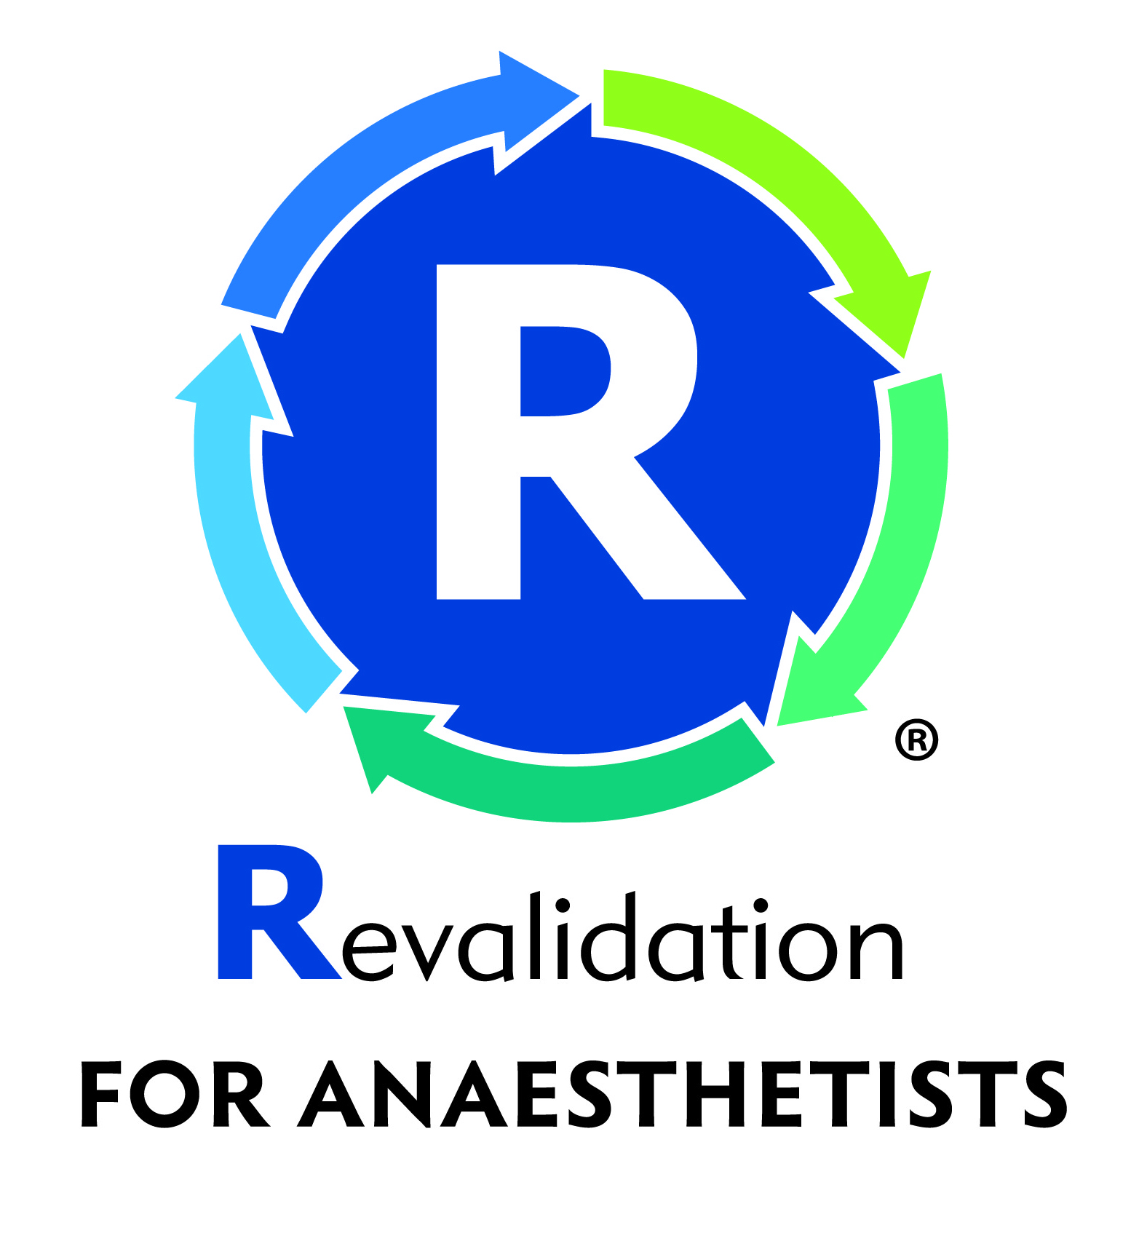

**DR GRAY’S INTERNATIONAL AIRWAY DAY ELGIN**

Alexander Graham Bell Centre Moray College University of the Highlands and Islands Moray Street, Elgin, Moray, IV30 1JJ

**10 June 2017**

**Registration Form**

Please print (one form per delegate)

Name: ______________________________________________________________

Address: ____________________________________________________________

Telephone number : _______________ Email: ___________________________

I enclose the following registration fee :

**Registration Fee and GALA Dinner :**

**□** ODPs / Nurses **£ 75 (**Fee and dinner £50+ £ 25)

**□** Trainee Doctors **£ 85** (Fee and dinner £60 + £ 25)

**□** Senior Doctors & Consultants **£ 100** (Fee and dinner £75 + £ 25)

Please return form and payment (cheque, made payable to **NHS Grampian** or cash)

to Michele Fischer, Theatre, Dr Gray’s Hospital, Elgin IV30 1SN.

✀.................................................✀......................................................................................

**For Office use only**

Name: .................................................................. Date: ...............................

**□**ODPs /Nurses £75 **□**Trainee Doctors £85 **□**Senior Doctors & Consultants £100

Paid:  **□** Cash £ ..........  **□** Cheque £ ..........

** #RCoA25** **@DrGraysDays**

[**https://www.facebook.com/DrGraysDays/**](https://www.facebook.com/DrGraysDays/)